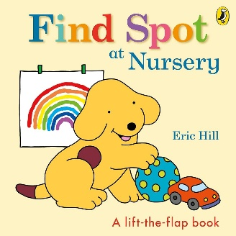
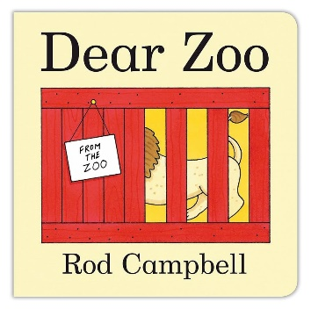
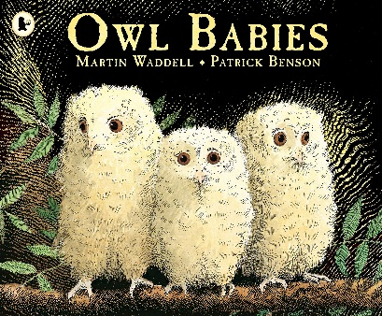

Core Texts

Understanding the World
Key learning:
- To talk about the members of their family
- Name and describe people who are familiar to them
- Have a growing sense of community and belongingness
How you can help from home:
- Explore family photographs together and talk about special family memories
- Consider creating a ‘special people’ book for your child to explore independently

Expressive Arts and Design
Key learning:
- To engage in a range of mark making activities
- To describe the marks they make and ascribe meaning to them
- To engage in simple pretend play
How you can help from home:
- Look at interesting pictures, art work and discuss what you see
- Provide opportunities to further develop your child’s creative interests

Numeracy
Key learning:
- To join in with numerical rhymes and songs
- To further develop number knowledge within three
- To identify and name common 2D shapes
How you can help from home:
- Play mathematical games together
- Sing number rhymes and songs, encouraging the children to use their fingers to represent numbers

Literacy
Key learning:
- To listen with increased attention to a range of rhymes, songs and stories
- To begin to anticipate what might happen next
- To tune into the environmental sounds around them
How you can help from home:
- Read books with expression and exciting voices
- Play sound games together that promote children tuning into environmental noises
:

Physical Development
Key learning:
- To begin to develop spatial awareness
- To begin to develop co-ordination and balance
- To develop fine motor control and begin to use one-handed tools
How you can help from home:
- Visit large open spaces and parks regularly
- Provide opportunities to develop their fine motor skills, such as play dough, sensory play or creative activities.

PSED
Key learning:
- Transition into school life
- Learning rules and routines
- Developing positive relationships
How you can help from home:
- Talk about your daily routine
- Ask your child questions about their day
- Praise positive efforts and progress

Communication and Language
Key learning:
- To develop attention and listening skills
- To join in with familiar nursery rhymes and songs
- To listen with increased attention to stories
How you can help from home:
- Sing rhymes and read stories daily
- Play listening and attention games together
- Narrate your day, pointing out things you observe around your environment

EYFS Mid-Term Planning
Nursery Autumn 1
Topics: ‘All About Me’ and ‘My Favourite Stories’

